Arquitetura MySQL
sábado, 24 de março de 2018
02:44
https://acaciolrdba.wordpress.com/ | https://comunidademysql.com.br/
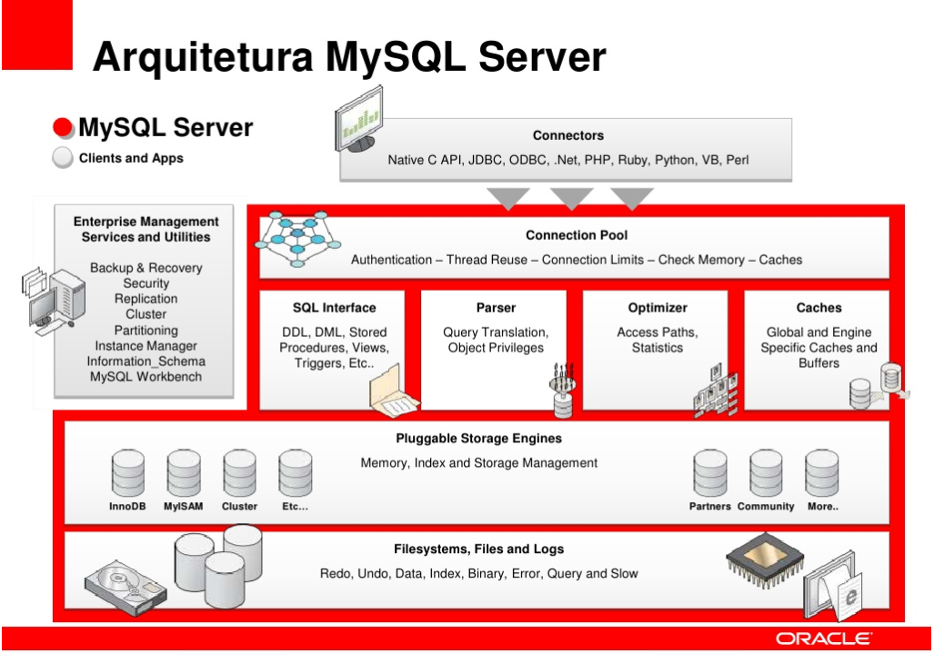
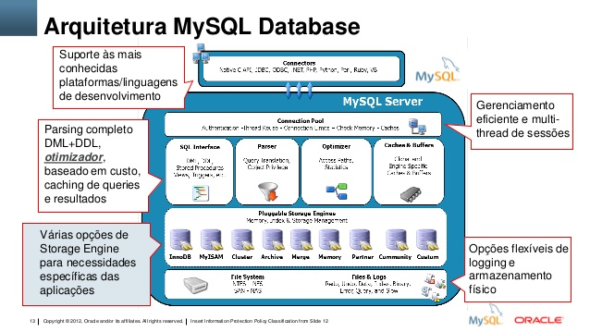

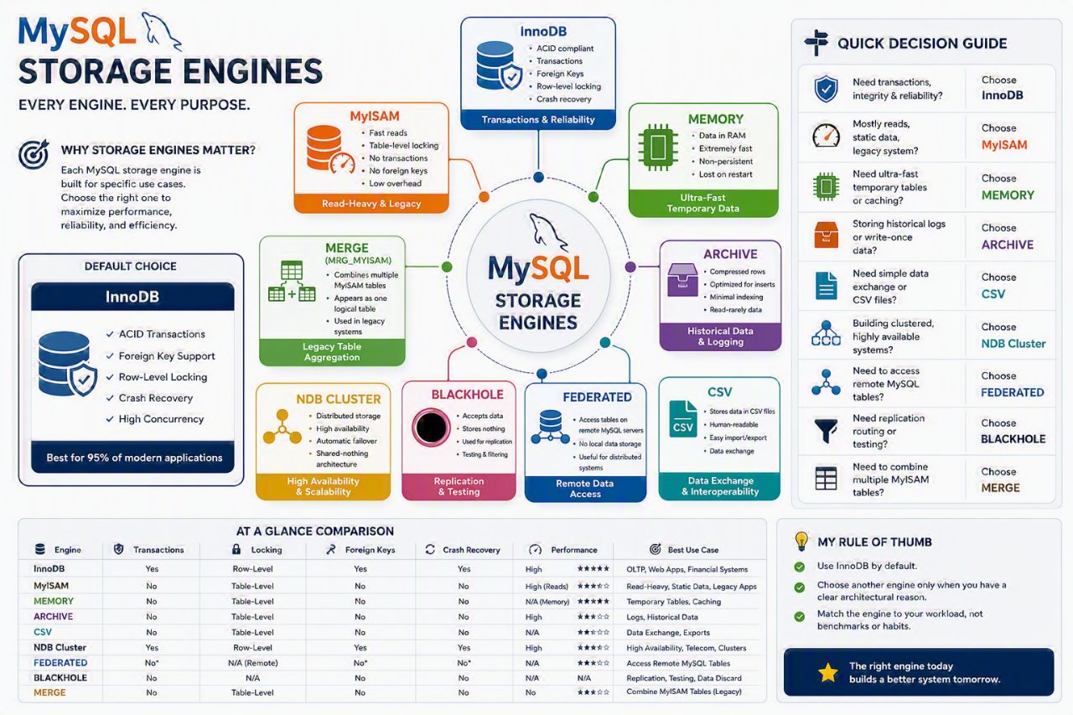

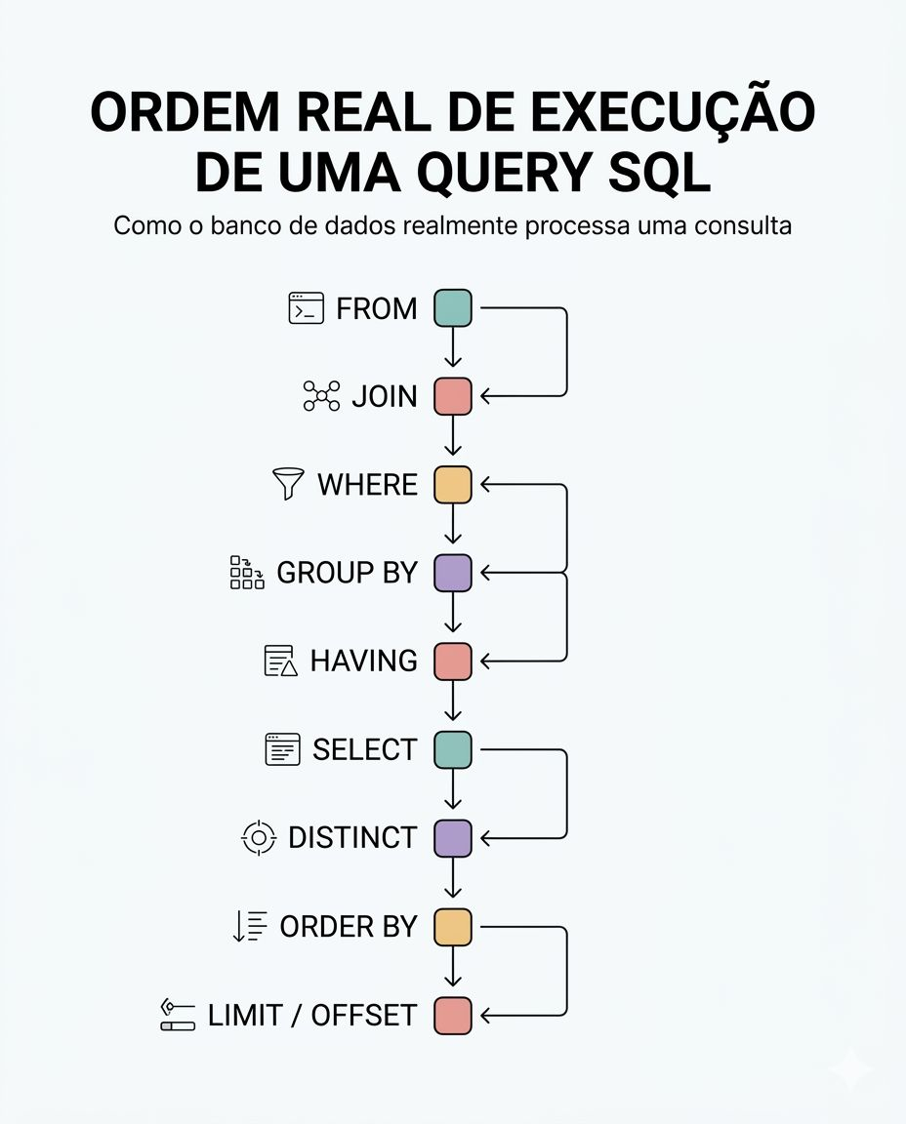

MySQL 8 InnoDB Architecture :
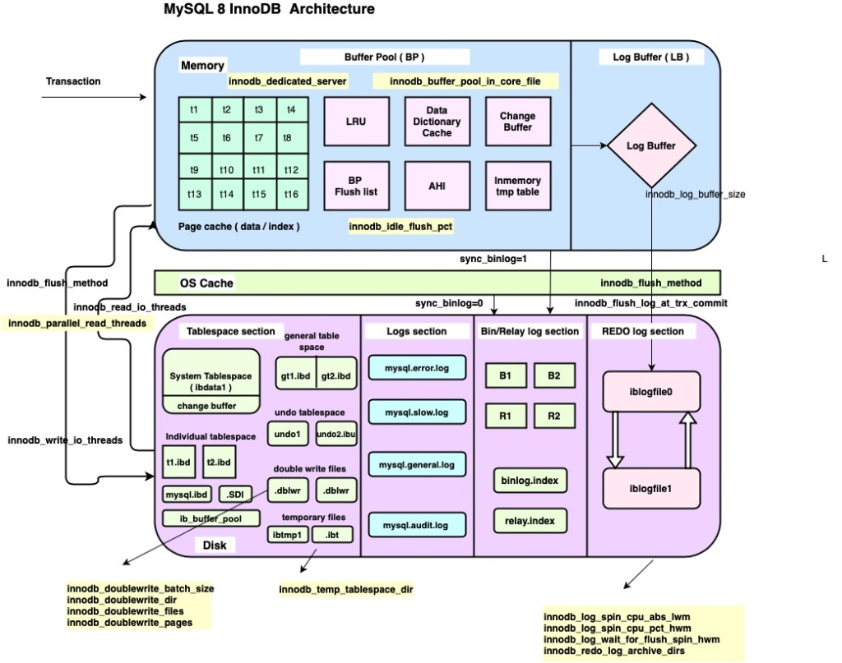
  - For understand the diagram better , I have added some old variables as well ( sync_binlog / innodb_log_buffer / innodb_flush_log_at_trx_commit / innodb_flush_method etc .. )
  - I have marked the MySQL 8 variables with yellow colour .
MySQL 8 variables :
  - innodb_buffer_pool_in_core_file ( 8.0.14 )
  - innodb_doublewrite_batch_size (8.0.20)
  - innodb_doublewrite_dir (8.0.20)
  - innodb_doublewrite_files (8.0.20)
  - innodb_doublewrite_pages (8.0.20)
  - innodb_fsync_threshold (8.0.13)
  - innodb_idle_flush_pct (8.0.18)
  - innodb_log_checkpoint_fuzzy_now (8.0.13)
  - innodb_parallel_read_threads (8.0.14)
  - innodb_redo_log_archive_dirs (8.0.17)
  - innodb_spin_wait_pause_multiplier (8.0.16)
  - innodb_temp_tablespaces_dir (8.0.13)
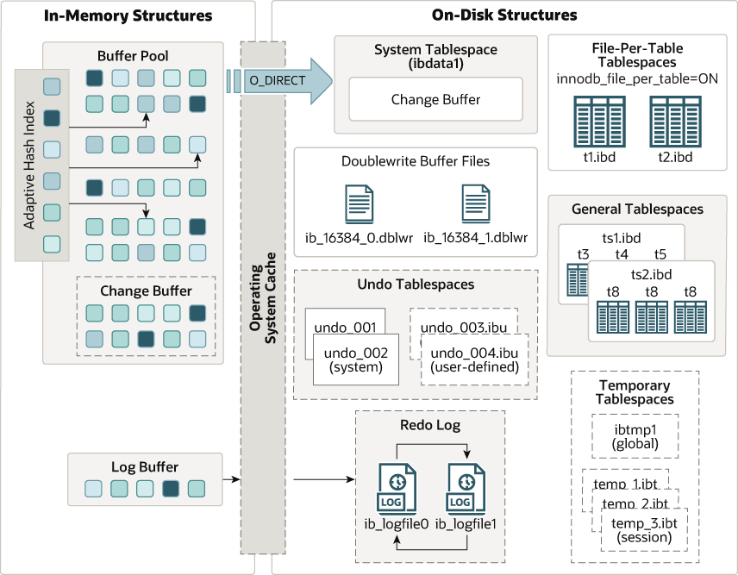

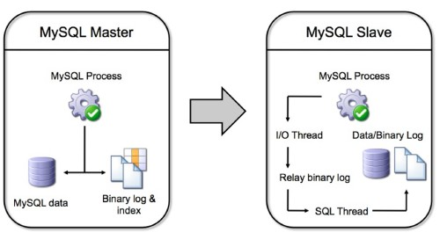

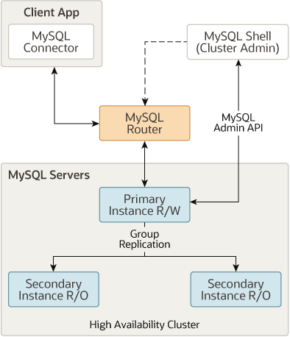
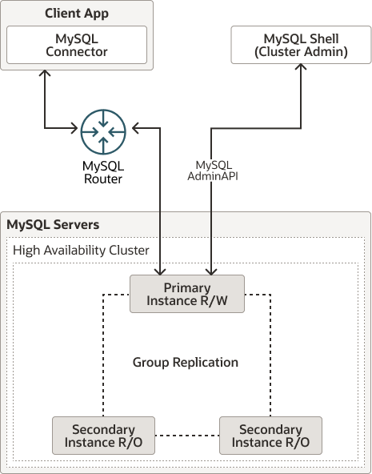

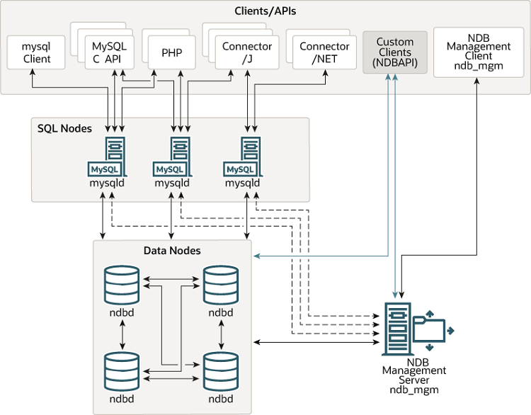

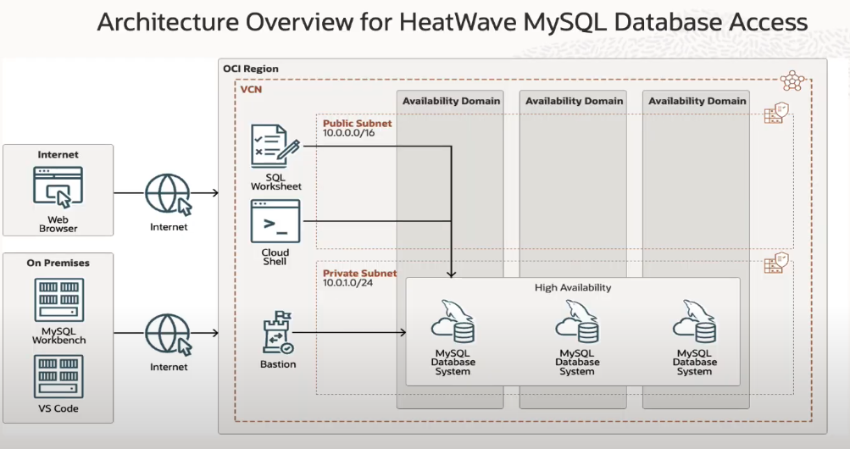

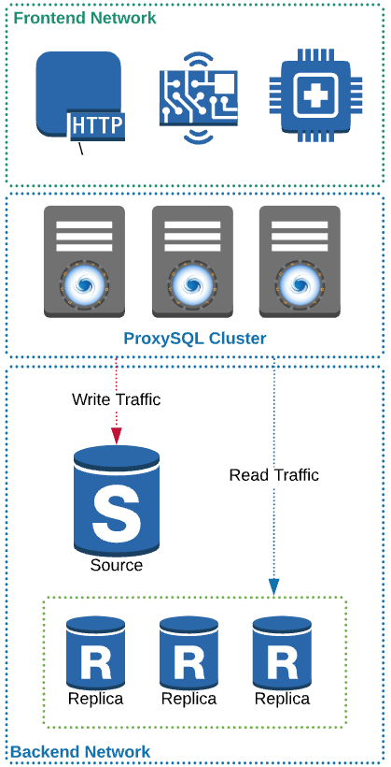

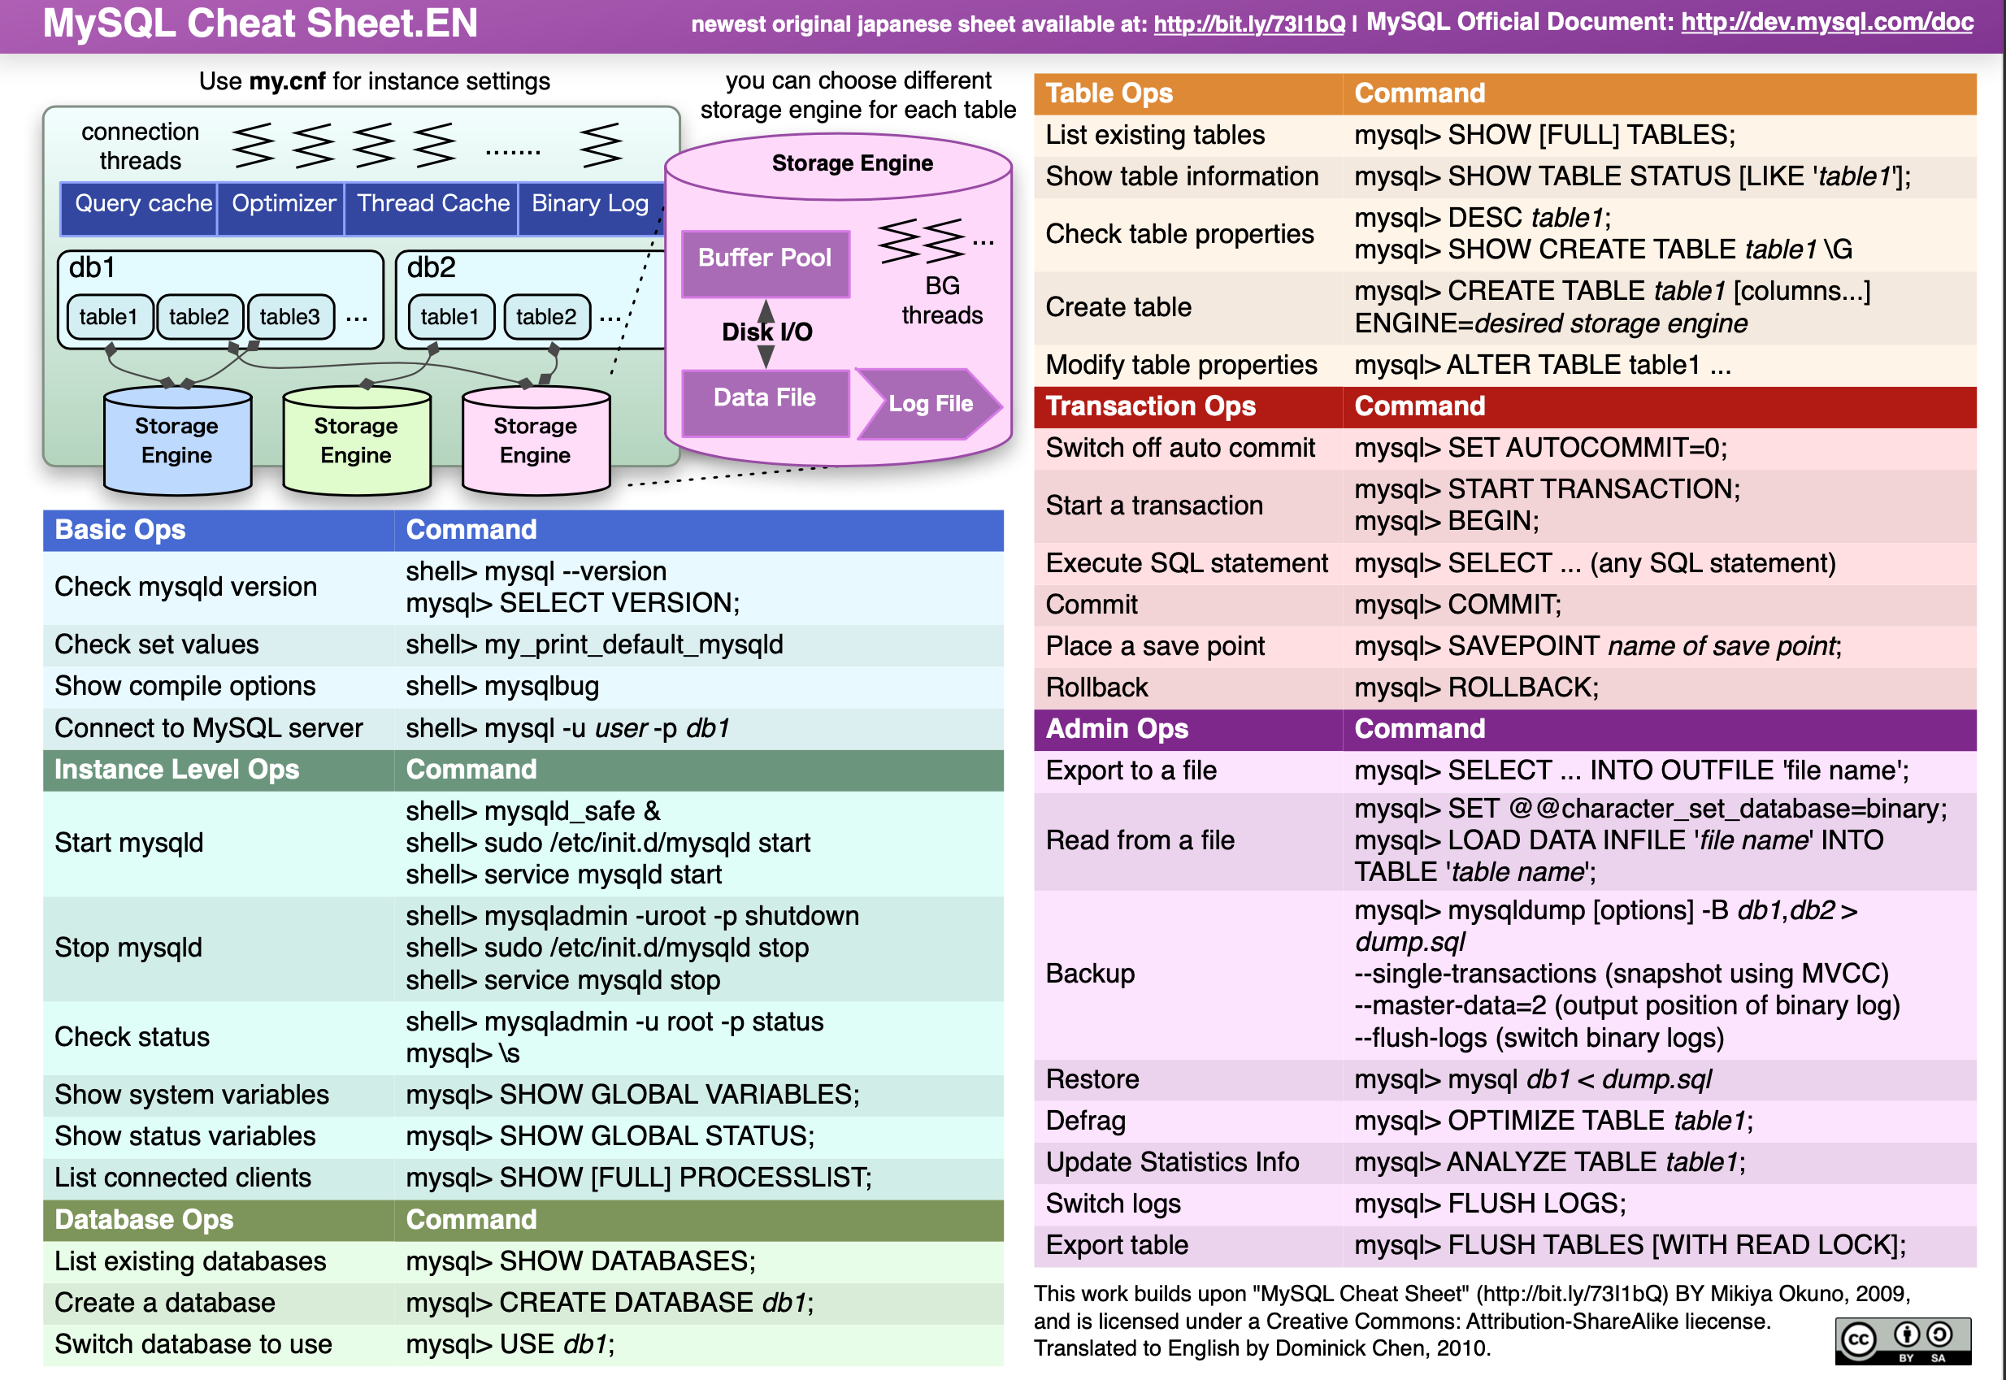

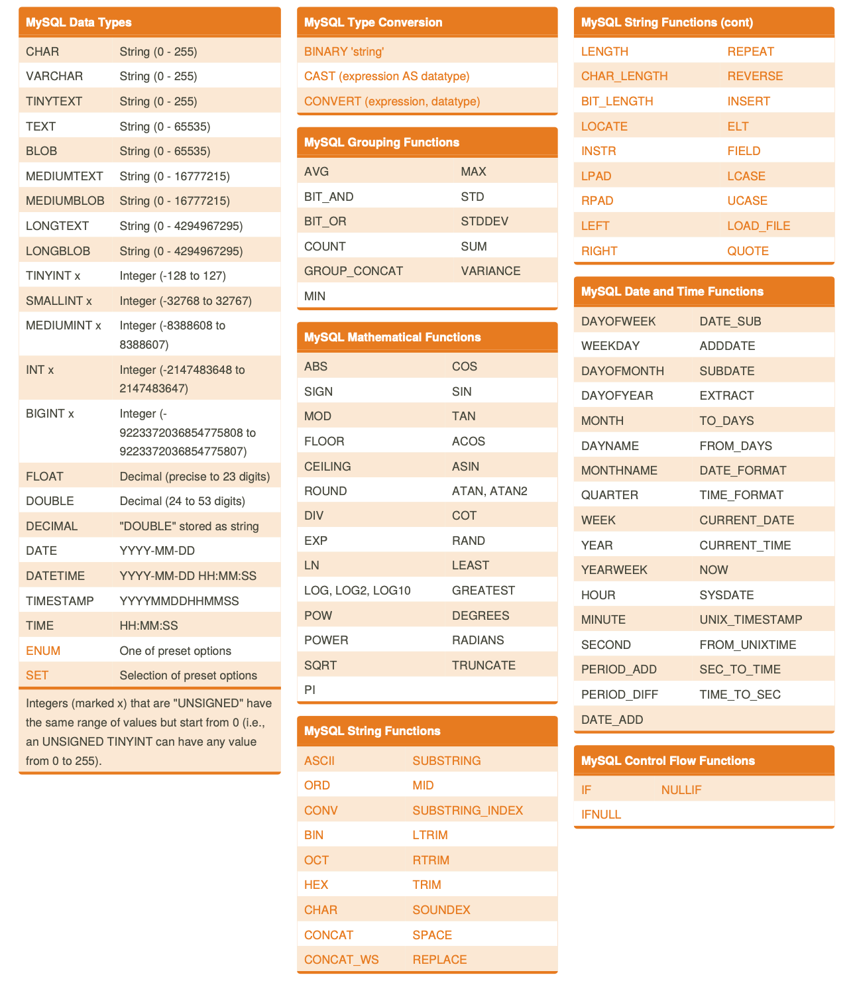
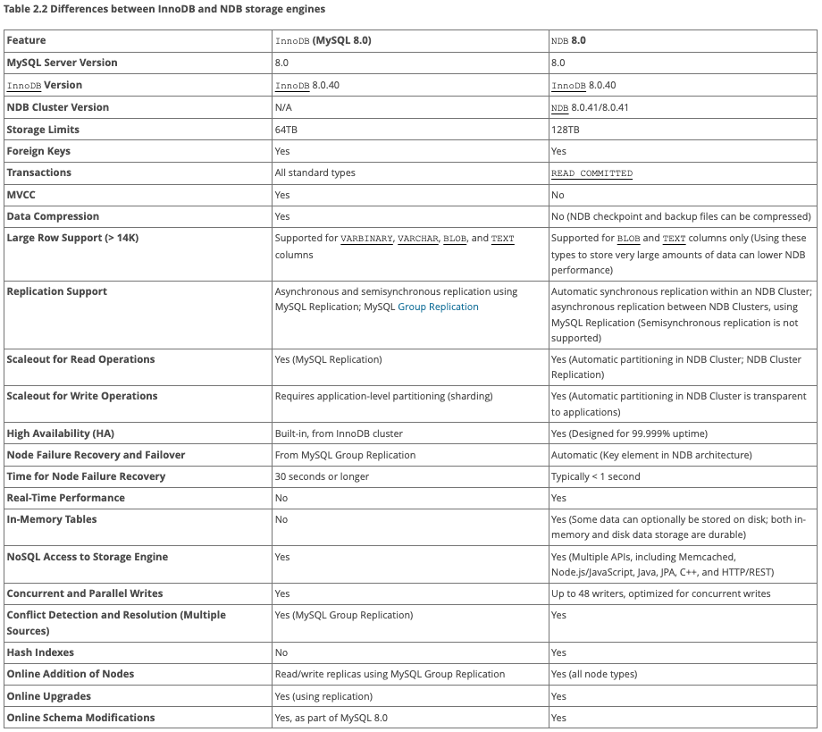
https://dev.mysql.com/doc/mysql-cluster-excerpt/8.0/en/mysql-cluster-ndb-innodb-engines.html

